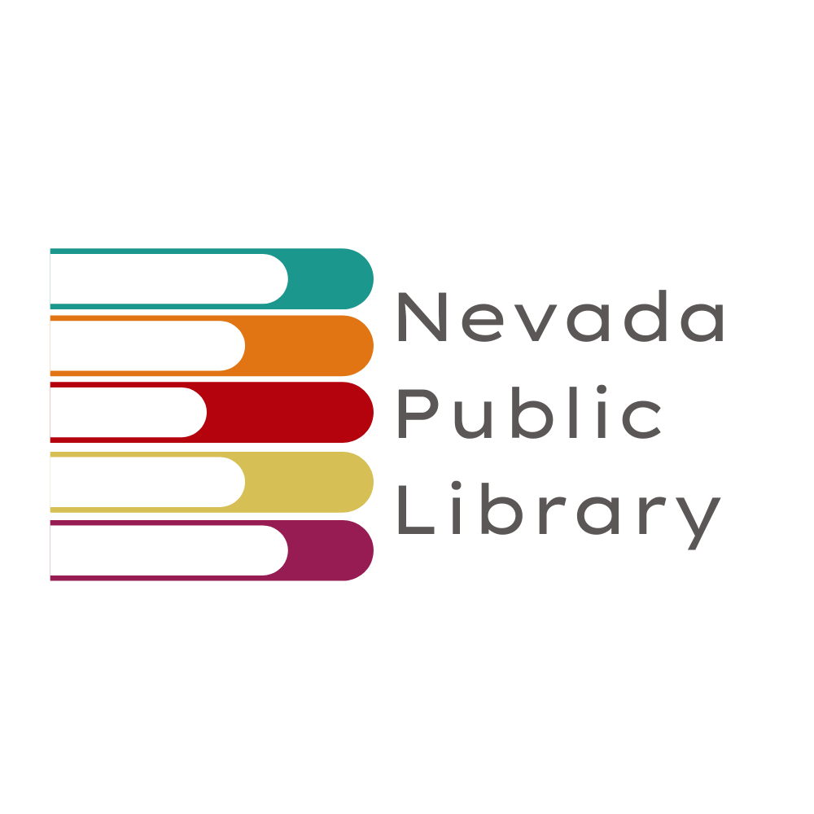
Nevada Public Library
nplmo.org • (417) 448-2770 • 218 W. Walnut St Nevada, MO 64772
JOB ANNOUNCEMENT
LIBRARY ASSISTANT / CIRCULATION SERVICES
Nevada Public Library
November 15, 2021
POSITION AVAILABLE: LIBRARY ASSISTANT / CIRCULATION SERVICES
HOURS/DAYS: Part Time (<20 hours/week)
DEADLINE: Applications will be accepted until position is filled.
DUTIES/RESPONSIBILITIES: Will be responsible for circulation, clerical and technical duties.
QUALIFICATIONS:
EDUCATION: Minimum of a GED or high school diploma is required.
HEALTH: Minor lifting, bending, stretching, & stamina.
DISPOSITION: Must be self motivated, adaptable, eager & able to learn.
Must be able to represent the library in a positive manner.
Displays enthusiasm/creativity.
Has a pleasant, professional demeanor.
Has the ability to work well with the public & co-workers.

SKILLS: Experience in customer service.
Ability to work with computers, phone system, & office machines.
Self-motivated.
Strong communications skills.

TRANSPORTATION: Must have reliable transportation to and from work.

HOURLY WAGE: $10.90/hr
APPLICATION: Please submit resume to : director@nplmo.org
or pick up/complete application at the library.
FOR FURTHER INFORMATION CONTACT:
Jodi Polk, Director
417-448-2770
Nevada Public Library is an equal opportunity employer.

